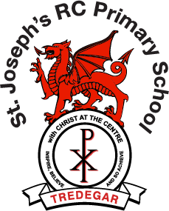

**School Uniform**

**Girls**

Sky Blue Sweatshirt or Cardigan (with school logo), White Polo Shirt, Grey Trousers (not leggings) or Grey Skirt/Pinafore Slip

Black School Shoes (not trainers)

In the summer they may wear sky blue/white summer dresses

**P.E. kit**

Plain White T Shirt, Plain Navy or Black Shorts & Trainers

**Boys**

Sky Blue Sweatshirt (with school logo), White Polo Shirt, & Grey School Trousers (not jogging bottoms)

Black School Shoes (not trainers)

**P.E. Kit**

Plain White T Shirt, Plain Navy or Black Shorts & Trainers

**Nursery & Reception children may wear plain navy jogging bottoms**