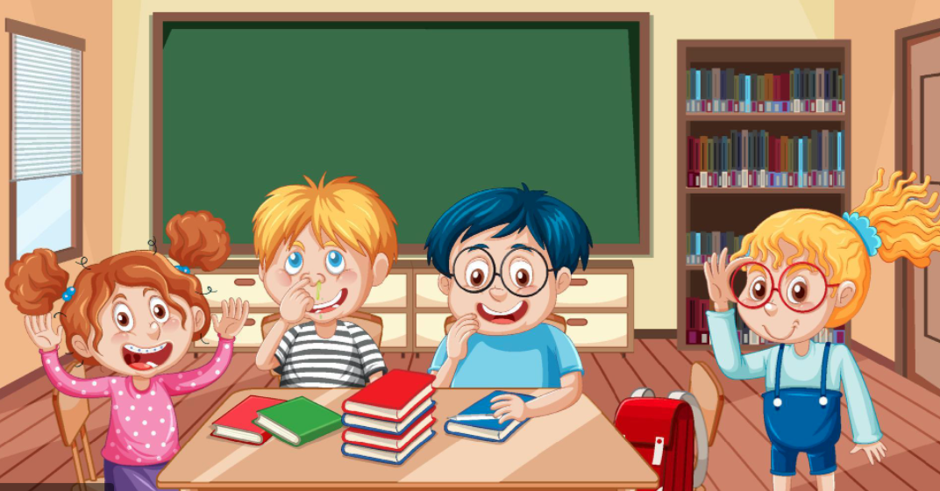 St. Joseph’s RC Primary School
Year 1 and 2 Welcome Newsletter – Autumn Term 2025

Dear Parent/Guardian,
We hope you all enjoyed a lovely summer break. We are ready for a busy term ahead, settling your child into the rules and routines of the class. Please ensure your child is in every day, attendance is very important.
School blue door will open at 8:50am and close promptly at 8:55am. Lateness affects your child’s learning.
We want to share your child’s learning journey with you so follow us on X/Twitter - @StjoseRC1. Lots of information on www.stjosephs.cymru
If you have any questions regarding your child and their education, please do not hesitate to phone the office and I will telephone you back at a convenient time.
Miss Lawrence

Topic for Autumn Term:
Marvellous Me / Castles
Looking at us and our bodies
Exploring castles
Parts of a castle
Roles of the people in a castle
What did people eat?
Locating castles in Wales
A visit to Caldicot castle
Read the Rapunzel story
Non-chronological report on castles

?

A
Religious Education themes for this term will be:
- Creation and Covenant
- Prophecy and Promise
We will also be celebrating Advent and the birth of Jesus.
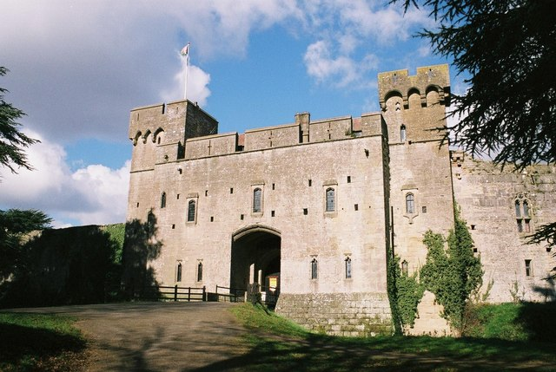



Home School Learning
READING - Reading is a very important part of your child’s development and learning. Reading and sharing books can support your child’s development. Please continue reading at home.
Reading books can be returned any day. We will aim to change the book that day or the following day.

KEY WORDS – Please help your child to learn the key words. Children will be assessed in school every FRIDAY.

HOME LEARNING PACKS – Learning Packs will begin to come home this term. They will be sent home every fortnight. In the past, there has been a poor uptake in completing and returning the packs last term. PLEASE MAKE EVERY EFFORT TO ENGAGE AND COMPLETE THE ACTIVITIES WITH YOUR CHILD. They will be sent home on a FRIDAY and must be returned by the following TUESDAY.

General Reminders…
- We are a NUT FREE SCHOOL. No nut products to be brought into school. Please check all packaging.
- Children will be doing PE on a THURSDAY. Please send PE kit into school with your child on that day – white t-shirt and black shorts/joggers/leggings and black daps or trainers.
- Children will be swimming in the summer term. Children will need swimsuit or swim shorts and a towel. Long hair to be tied back and earrings taken out.
- We enjoy outdoor learning at St Joseph’s so please ensure your child has appropriate footwear and coat each day. You can leave wellies in school, so your child has regular access to them.
- Please provide your child with a bottle, filled with water.
- Lunch bags, jumpers and coats need to be labelled clearly with your child’s name.
- Children are not encouraged to bring toys (Poppets etc) or pencil cases into the class.
- Please ensure your child comes to school wearing the correct uniform. A pale blue St Joseph’s jumper/cardigan, white shirt/polo shirt, grey/black trousers, skirt or pinafore and black shoes.

